Requesting DIRM Files for Tailoring  
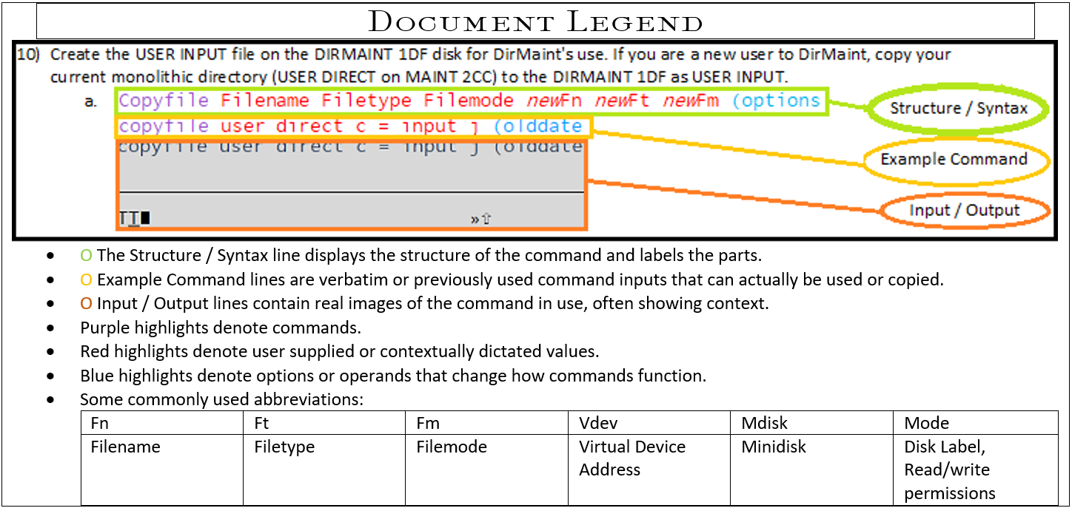

1. Request a copy of the file you want to edit, open it in Xedit, make the desired changes to the file, and file it within Xedit and DIRM.
2. DIRM send filename filetype  
   dirm send authfor control  
   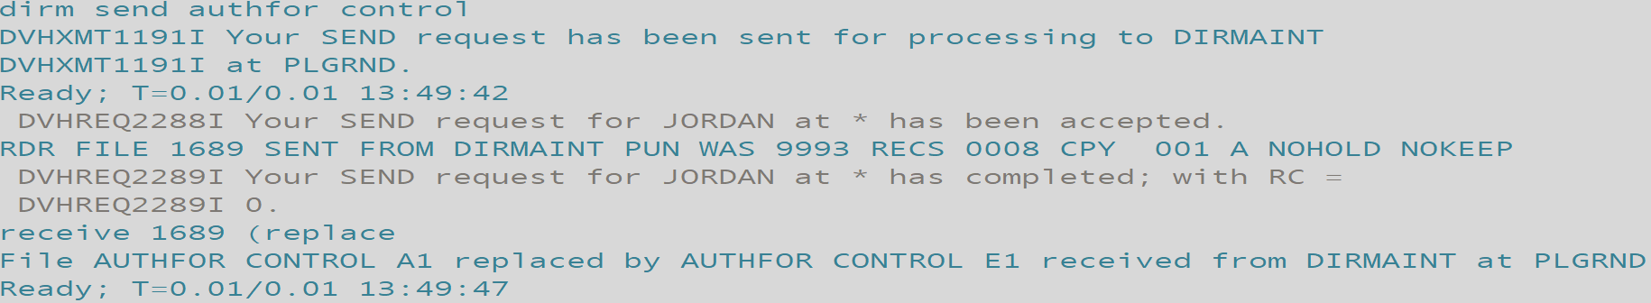
3. receive fileid (option  
   receive 1689 (replace  
   
4. Xedit filename filetype filemode  
   xedit authfor control   
   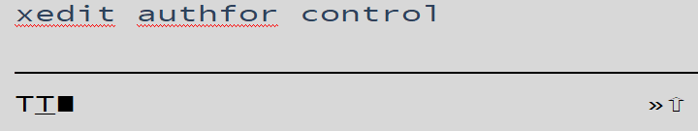
5. Save and submit changes to the file.  
   File  
   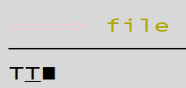
6. DIRM file filename filetype filemode  
   DIRM file authfor control 